EE4266 Assignment 2

Zhang Zeyu U1620474K

Part I: Determining the fundamental matrix

Picking points

Initially MATLAB corner detection method C = corner(I) was applied to find the points of interest. However, the effect did not meet the expectation:

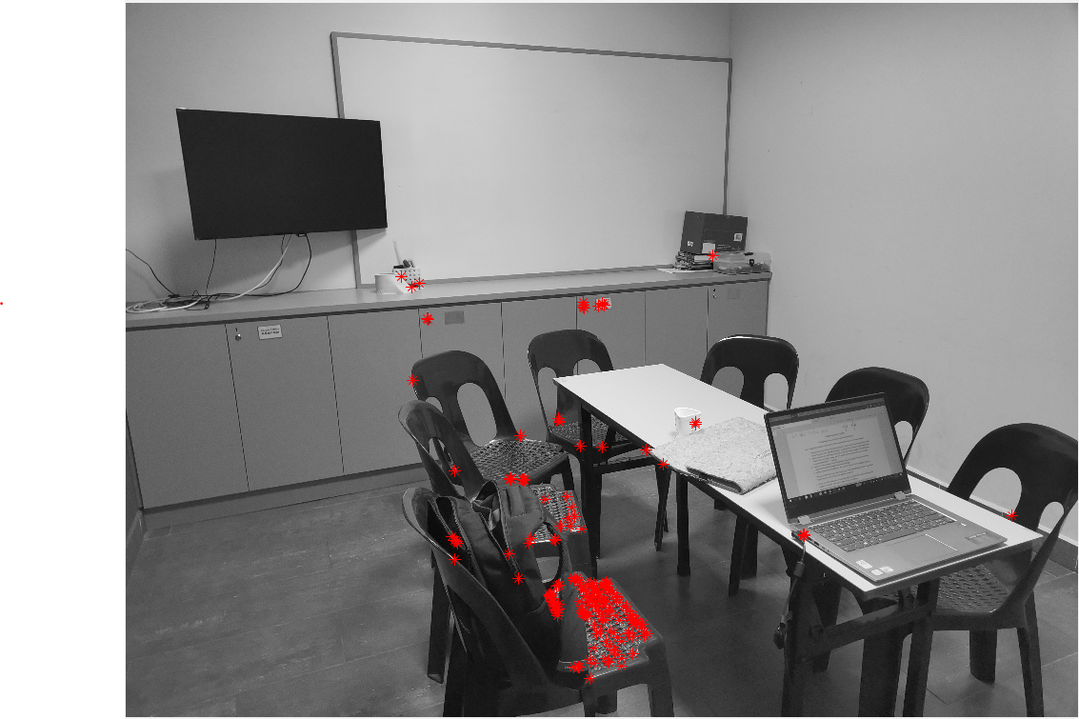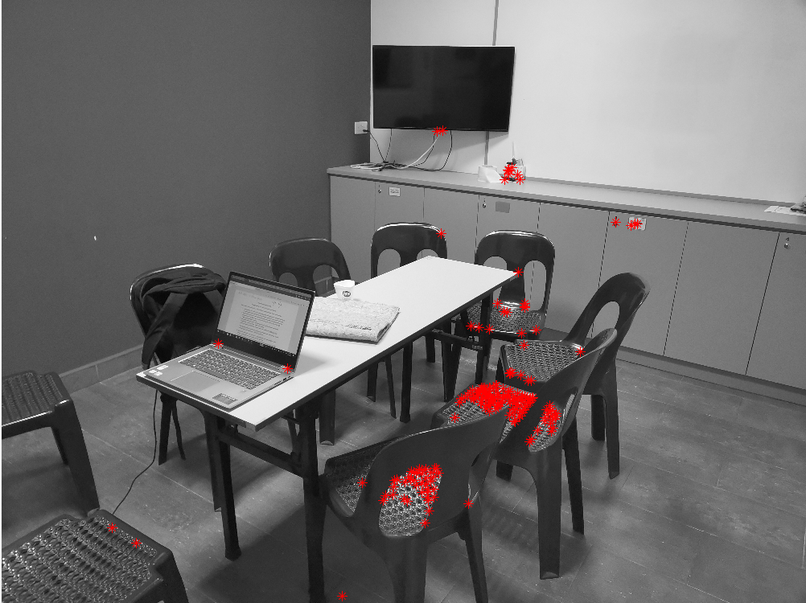

Figure 1 Figure 2

It can be seen that the points picked hardly represent some form of corners and there is no one-to-one correspondence. Therefore, the corner detection approach was abandoned due to its low robustness. Instead, 8 pairs of corresponding points were manually selected from two images respectively:

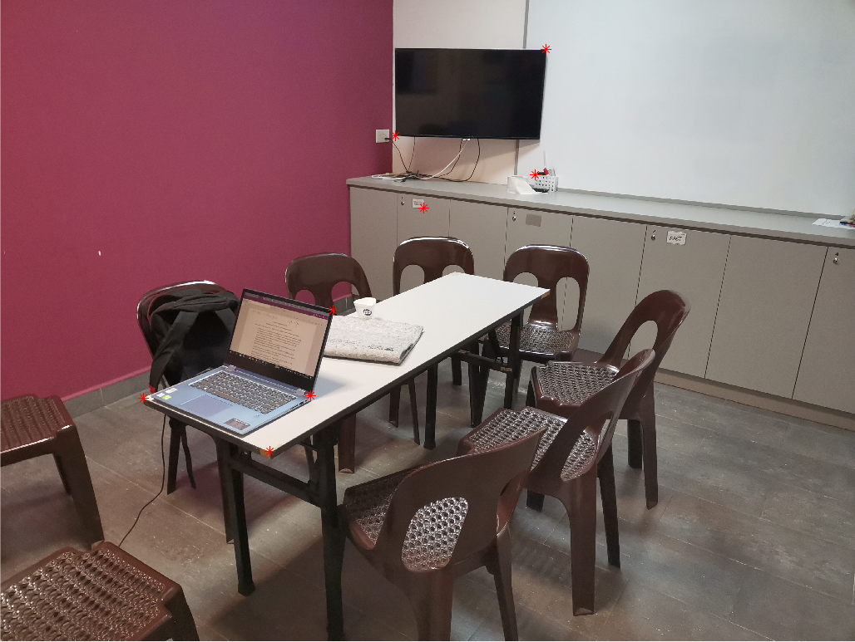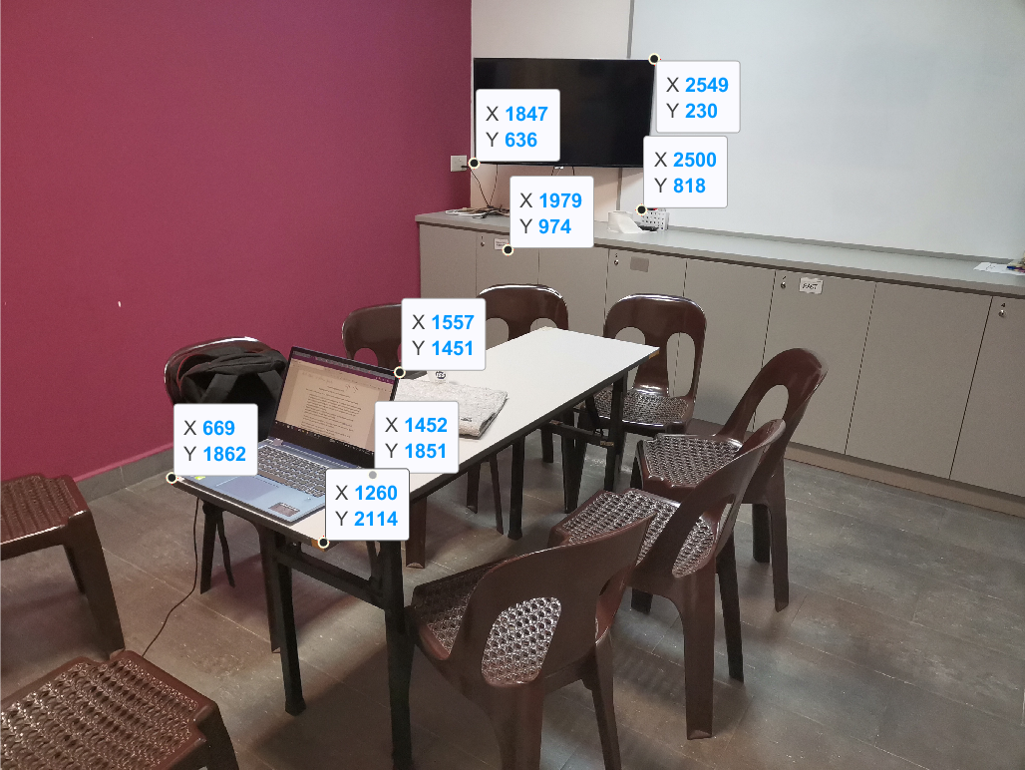

Figure 3 Figure 4

The coordinates of the points from the right image R are: (1557, 1451), (1452, 1851), (1260, 2114), (1847, 636), (669, 1862), (2549, 230), (1979, 974), (2500, 818).

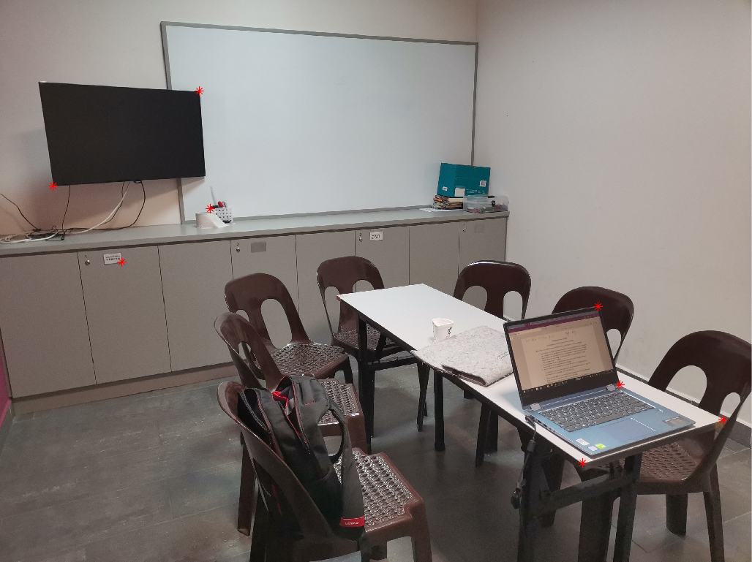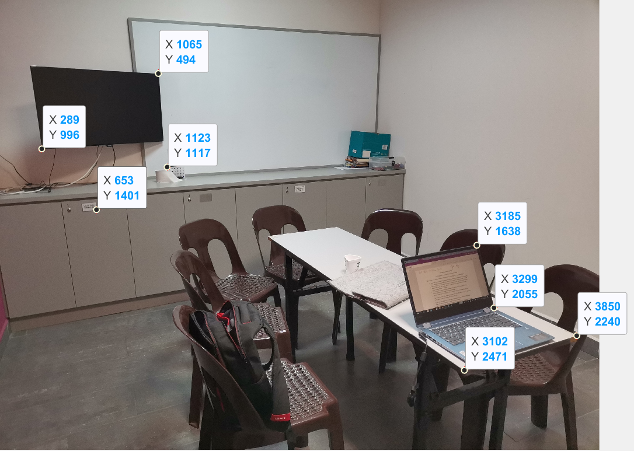

Figure 5 Figure 6

The coordinates of the corresponding points from the left image L are: (3185, 1638), (3299, 2055), (3850, 2240), (289, 996), (3102, 2471), (1065, 494), (653, 1401), (1123, 1117).

We use the technique provided in the notes to compute the fundamental matrix:

Arrange the points’ coordinates and the elements of fundamental matrix into a linear system of equations:

$$\left(\begin{matrix}u_{1}{u_{1}}^{'} & u_{1}{v_{1}}^{'} & u_{1} & v_{1}{u_{1}}^{'} & v_{1}{v_{1}}^{'} & v_{1} & {u_{1}}^{'} & {v_{1}}^{'} \\ u_{2}{u_{2}}^{'} & u_{2}{v_{2}}^{'} & u_{2} & v_{2}{u_{2}}^{'} & v_{2}{v_{2}}^{'} & v_{2} & {u_{2}}^{'} & {v_{2}}^{'} \\ u_{3}{u_{3}}^{'} & u_{3}{v_{3}}^{'} & u_{3} & v_{3}{u_{3}}^{'} & v_{3}{v_{3}}^{'} & v_{3} & {u_{3}}^{'} & {v_{3}}^{'} \\ u_{4}{u_{4}}^{'} & u_{4}{v_{4}}^{'} & u_{4} & v_{4}{u_{4}}^{'} & v_{4}{v_{4}}^{'} & v_{4} & {u_{4}}^{'} & {v_{4}}^{'} \\ u_{5}{u_{5}}^{'} & u_{5}{v_{5}}^{'} & u_{5} & v_{5}{u_{5}}^{'} & v_{5}{v_{5}}^{'} & v_{5} & {u_{5}}^{'} & {v_{5}}^{'} \\ u_{6}{u_{6}}^{'} & u_{6}{v_{6}}^{'} & u_{6} & v_{6}{u_{6}}^{'} & v_{6}{v_{6}}^{'} & v_{6} & {u_{6}}^{'} & {v_{6}}^{'} \\ u_{7}{u_{7}}^{'} & u_{7}{v_{7}}^{'} & u_{7} & v_{7}{u_{7}}^{'} & v_{7}{v_{7}}^{'} & v_{7} & {u_{7}}^{'} & {v_{7}}^{'} \\ u_{8}{u_{8}}^{'} & u_{8}{v_{8}}^{'} & u_{8} & v_{8}{u_{8}}^{'} & v_{8}{v_{8}}^{'} & v_{8} & {u_{8}}^{'} & {v_{8}}^{'}\end{matrix}\right)\left(\begin{matrix}F_{11} \\ F_{12} \\ F_{13} \\ F_{21} \\ F_{22} \\ F_{23} \\ F_{31} \\ F_{32}\end{matrix}\right)=-\left(\begin{matrix}1 \\ 1 \\ 1 \\ 1 \\ 1 \\ 1 \\ 1 \\ 1\end{matrix}\right)$$

Where $\left(u_{i},v_{j}\right)$ and $\left({u_{i}}^{'},{v_{j}}^{'}\right)$ denote the coordinates of the points from image R and L respectively. （note that the convention adapted here is different from the one given in the notes. Nevertheless, as shown later in part II and III, it produces correct epipolar lines so this convention is consistent with the one in the notes. ）

Substitute in the values found from image L and R:

$$\left(\begin{matrix}(1557)(3185) & (1557)(1638) & 1557 & (1451)(3185) & (1451)(1638) & 1451 & 3185 & 1638 \\ (1452)(3299) & (1452)(2055) & 1452 & (1851)(3299) & (1851)(2055) & 1851 & 3299 & 2055 \\ (1260)(3850) & (1260)(2240) & 1260 & (2114)(3850) & (2114)(2240) & 2114 & 3850 & 2240 \\ (1847)(289) & (1847)(996) & 1847 & (636)(289) & (636)(996) & 636 & 289 & 996 \\ (669)(3102) & (669)(2471) & 669 & (1862)(3102) & (1862)(2471) & 1862 & 3102 & 2471 \\ (2549)(1065) & (2549)(494) & 2549 & (230)(1065) & (230)(494) & 230 & 1065 & 494 \\ (1979)(653) & (1979)(1401) & 1979 & (974)(653) & (974)(1401) & 974 & 653 & 1401 \\ (2500)(1123) & (2500)(1117) & 2500 & (818)(1123) & (818)(1117) & 818 & 1123 & 1117\end{matrix}\right)\left(\begin{matrix}F_{11} \\ F_{12} \\ F_{13} \\ F_{21} \\ F_{22} \\ F_{23} \\ F_{31} \\ F_{32}\end{matrix}\right)=-\left(\begin{matrix}1 \\ 1 \\ 1 \\ 1 \\ 1 \\ 1 \\ 1 \\ 1\end{matrix}\right)$$

Use the augmented matrix representation:

$$\left(\begin{matrix}(1557)(3185) & (1557)(1638) & 1557 & (1451)(3185) & (1451)(1638) & 1451 & 3185 & 1638 \\ (1452)(3299) & (1452)(2055) & 1452 & (1851)(3299) & (1851)(2055) & 1851 & 3299 & 2055 \\ (1260)(3850) & (1260)(2240) & 1260 & (2114)(3850) & (2114)(2240) & 2114 & 3850 & 2240 \\ (1847)(289) & (1847)(996) & 1847 & (636)(289) & (636)(996) & 636 & 289 & 996 \\ (669)(3102) & (669)(2471) & 669 & (1862)(3102) & (1862)(2471) & 1862 & 3102 & 2471 \\ (2549)(1065) & (2549)(494) & 2549 & (230)(1065) & (230)(494) & 230 & 1065 & 494 \\ (1979)(653) & (1979)(1401) & 1979 & (974)(653) & (974)(1401) & 974 & 653 & 1401 \\ (2500)(1123) & (2500)(1117) & 2500 & (818)(1123) & (818)(1117) & 818 & 1123 & 1117\end{matrix} | \begin{matrix}-1 \\ -1 \\ -1 \\ -1 \\ -1 \\ -1 \\ -1 \\ -1\end{matrix}\right)$$

Use Gaussian elimination to obtain its reduced row echelon form by using the MATLAB command ‘rref()’:

$$\left(\begin{matrix}1 & 0 & 0 & 0 & 0 & 0 & 0 & 0 \\ 0 & 1 & 0 & 0 & 0 & 0 & 0 & 0 \\ 0 & 0 & 1 & 0 & 0 & 0 & 0 & 0 \\ 0 & 0 & 0 & 1 & 0 & 0 & 0 & 0 \\ 0 & 0 & 0 & 0 & 1 & 0 & 0 & 0 \\ 0 & 0 & 0 & 0 & 0 & 1 & 0 & 0 \\ 0 & 0 & 0 & 0 & 0 & 0 & 1 & 0 \\ 0 & 0 & 0 & 0 & 0 & 0 & 0 & 1\end{matrix} | \begin{matrix}0 \\ 0 \\ -0.001574803149606 \\ 0 \\ 0 \\ -0.013986013986014 \\ -0.001457725947522 \\ 0.008064516129032\end{matrix}\right)$$

Therefore we have:

$F_{11}=0$, $F_{12}=0$, $F_{13}=-0.001574803149606$, $F_{21}=0$, $F_{22}=0$, $F_{23}=-0.013986013986014$, $F_{31}=-0.001457725947522$, $F_{32}=0.008064516129032$.

Therefore, the fundamental matrix

$F=\left(\begin{matrix}0 & 0 & -0.001574803149606 \\ 0 & 0 & -0.013986013986014 \\ -0.001457725947522 & 0.008064516129032 & 1\end{matrix}\right)$

We check that $F$ is rank-2 which satisfies the rank deficiency constraint.

Proof check:

Let $x_{i}=\left(\begin{matrix}u_{i} & v_{i} & 1\end{matrix}\right)$, ${x'}_{i}=\left(\begin{matrix}{u'}_{i} & {v'}_{i} & 1\end{matrix}\right)$ to be the homogeneous coordinates of image R and L respectively.

$x_{i}F{{x'}_{i}}^{T}=\left(\begin{matrix}-13.1788545211460 \\ -13.8363801674481 \\ -18.0984143038652 \\ -3.19279104674517 \\ -10.6899478834197 \\ -3.79956361149804 \\ -5.39242100240594 \\ -7.00652903751292\end{matrix}\right)$ for integer $i$ ranges from 1 to 8

This result has observable discrepancy since we expect $x_{i}F{{x'}_{i}}^{T}=0$. This might arise of the floating-point error during the matrix manipulation and computation. Therefore, it is necessary to test different alternative methods of solving the linear system and choose the one with minimum error.

Alternative methods:

1. MATLAB System of Linear Equations solver:

X = linsolve(A,B)

Produced the following results:

$F_{11}=4.98845848000000e-07$, $F_{12}=1.65720528300000e-06$, $F_{13}=-0.00157397941783700$, $F_{21}=1.76977692500000e-06$, $F_{22}=-7.25449046000000e-07$, $F_{23}=-0.0139788539625590$, $F_{31}=-0.00145691093589900$, $F_{32}=0.00807037768992400$.

The fundamental matrix is now

$F=\left(\begin{matrix}4.98845848000000e-07 & 1.65720528300000e-06 & -0.00157397941783700 \\ 1.76977692500000e-06 & -7.25449046000000e-07 & -0.0139788539625590 \\ -0.00145691093589900 & 0.00807037768992400 & 1\end{matrix}\right)$

However, after checking $F$ is rank-3. Therefore, we need to manually impose the rank deficient constraint (it can be shown that fundamental matrix is rank-2).

Apply singular value decomposition to $F$ by using MATLAB command [U,S,V] = svd(F):

$$F=USV^{T} (where U and V are orthogonal matrices and S is diagonal)=\left(\begin{matrix}-0.001573705267380 & -0.126238839372377 & 0.991998628469639 \\ -0.013976539886993 & -0.991900184796639 & -0.126248484082704 \\ 0.999901085000170 & -0.014063386303048 & -0.000203423628246\end{matrix}\right)$$

$$\left(\begin{matrix}1.000132554337549 & 0 & 0 \\ 0 & 0.000114522566732 & 0 \\ 0 & 0 & 0.000000575492986\end{matrix}\right)$$

$${\left(\begin{matrix}-0.001456599267397 & 0.163030624039341 & 0.986619933887369 \\ 0.008068517422849 & -0.986586948914469 & 0.163037085530370 \\ 0.999966388107706 & 0.008198039825642 & 0.000121646396493\end{matrix}\right)}^{T}$$

Set the smallest singular value of $F$ to be 0 and obtain the new matrix $F^{'}$:

$$F^{'}=\left(\begin{matrix}-0.001573705267380 & -0.126238839372377 & 0.991998628469639 \\ -0.013976539886993 & -0.991900184796639 & -0.126248484082704 \\ 0.999901085000170 & -0.014063386303048 & -0.000203423628246\end{matrix}\right)$$

$$\left(\begin{matrix}1.000132554337549 & 0 & 0 \\ 0 & 0.000114522566732 & 0 \\ 0 & 0 & 0\end{matrix}\right)$$

$${\left(\begin{matrix}-0.001456599267397 & 0.163030624039341 & 0.986619933887369 \\ 0.008068517422849 & -0.986586948914469 & 0.163037085530370 \\ 0.999966388107706 & 0.008198039825642 & 0.000121646396493\end{matrix}\right)}^{T}$$

$$=\left(\begin{matrix}-0.000000064403882 & 0.000001564129326 & -0.001573979487283 \\ 0.000001841459912 & -0.000000713603567 & -0.013978853953721 \\ -0.001456910820397 & 0.008070377709011 & 1.000000000000014\end{matrix}\right)$$

Proof check:

$x_{i}F'{{x'}_{i}}^{T}=\left(\begin{matrix}-2.67112634917550 \\ -3.92082633624158 \\ -2.35550833780380 \\ -0.451197639845997 \\ -0.854204084929073 \\ -1.62734281042060 \\ -0.924184786863956 \\ -1.76456596441808\end{matrix}\right)$ for integer $i$ ranges from 1 to 8

2. x=A\b

Let the left part of the augmented matrix be A, the right part be b,

Then the linear system can be solved with MATLAB code x=A\b. The elements of F obtained are:

$F_{11}=0.000000498845848$, $F_{12}=0.000001657205283$, $F_{13}=-0.001573979417837$, $F_{21}=0.000001769776925$, $F_{22}= -0.000000725449046$, $F_{23}= -0.013978853962559$, $F_{31}=-0.001456910935899$, $F_{32}=0.008070377689924$.

It is obvious that the result is the same as obtained by using linsolve(A,B).

3. Solving overdetermined linear system through singular value decomposition

We find two more pair points on the image L and R:

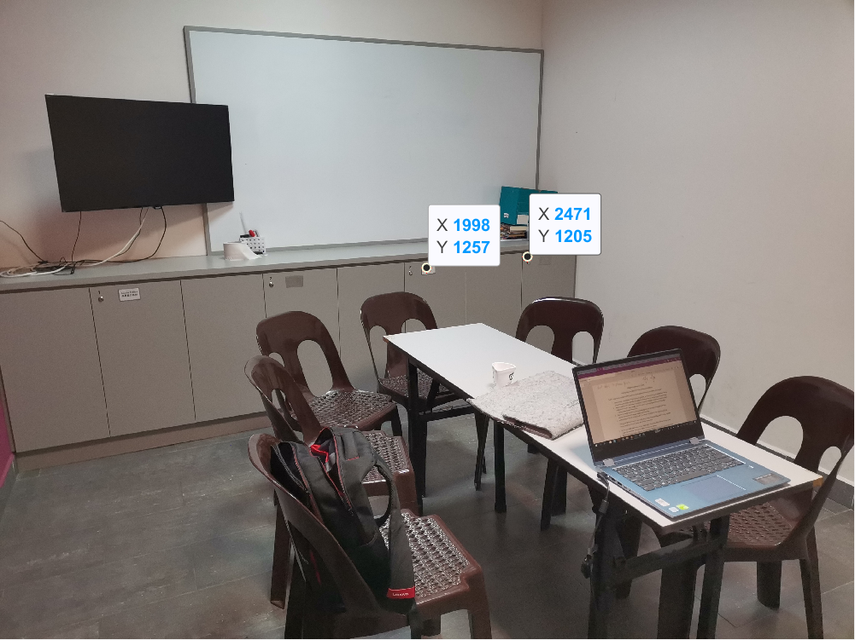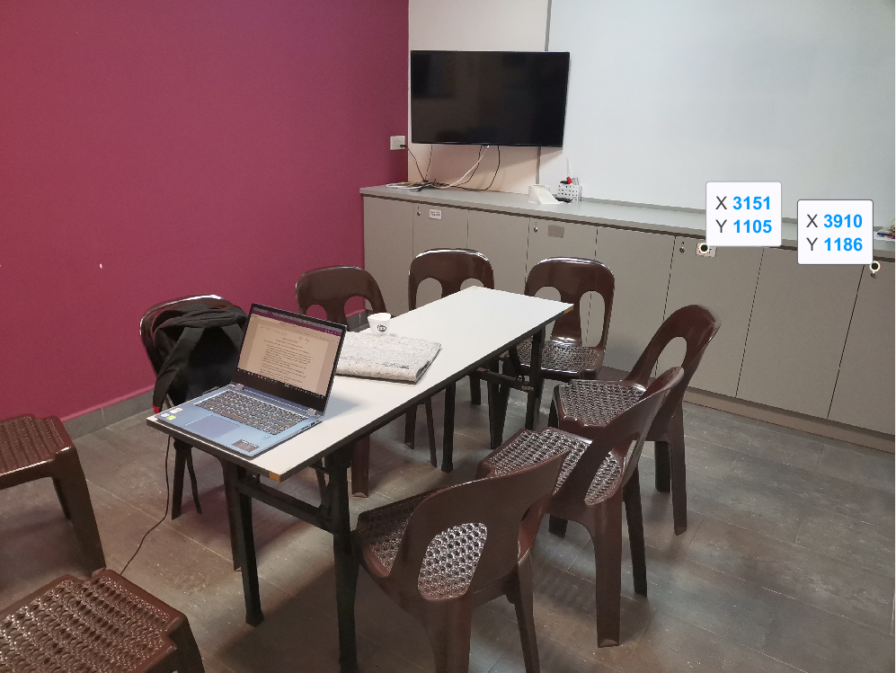

Figure 7 Figure 8

With these two additional pairs we form a new augmented matrix: $$\left(\begin{matrix}(1557)(3185) & (1557)(1638) & 1557 & (1451)(3185) & (1451)(1638) & 1451 & 3185 & 1638 \\ (1452)(3299) & (1452)(2055) & 1452 & (1851)(3299) & (1851)(2055) & 1851 & 3299 & 2055 \\ (1260)(3850) & (1260)(2240) & 1260 & (2114)(3850) & (2114)(2240) & 2114 & 3850 & 2240 \\ (1847)(289) & (1847)(996) & 1847 & (636)(289) & (636)(996) & 636 & 289 & 996 \\ (669)(3102) & (669)(2471) & 669 & (1862)(3102) & (1862)(2471) & 1862 & 3102 & 2471 \\ (2549)(1065) & (2549)(494) & 2549 & (230)(1065) & (230)(494) & 230 & 1065 & 494 \\ (1979)(653) & (1979)(1401) & 1979 & (974)(653) & (974)(1401) & 974 & 653 & 1401 \\ (2500)(1123) & (2500)(1117) & 2500 & (818)(1123) & (818)(1117) & 818 & 1123 & 1117 \\ (3151)(1998) & (3151)(1257) & 3151 & (1105)(1998) & (1105)(1257) & 1105 & 1998 & 1257 \\ (3910)(2471) & (3910)(1205) & 3910 & (1186)(2471) & (1186)(1205) & 1186 & 2471 & 1205\end{matrix} | \begin{matrix}-1 \\ -1 \\ -1 \\ -1 \\ -1 \\ -1 \\ -1 \\ -1 \\ -1 \\ -1\end{matrix}\right)$$

Use singular value decomposition to solve it (code: [U,S,V]=svd(A,0); x= V\*((U'\*b)./diag(S));):

$$F=\left(\begin{matrix}0.000000050632886 & 0.000001081864938 & -0.000910426999812 \\ 0.000000709546401 & -0.000000098515972 & -0.006672390044458 \\ -0.000226724039952 & 0.002912066941449 & 1\end{matrix}\right)$$

Checking that $F$ is rank-3. Impose the rank-deficient constraint:

$$F=USV^{T} (where U and V are orthogonal matrices and S is diagonal)=\left(\begin{matrix}-0.000910395451596 & -0.189601641260895 & 0.981860676884097 \\ -0.006672182283189 & -0.981838076559059 & -0.189603463582254 \\ 0.999977326324803 & -0.006723767543718 & -0.000371195792581\end{matrix}\right)$$

$$\left(\begin{matrix}1.000026940045751 & 0 & 0 \\ 0 & 0.000019705534707 & 0 \\ 0 & 0 & 0.000000000659575\end{matrix}\right)$$

$${\left(\begin{matrix}-0.000226717571822 & 0.041520314015871 & -0.999137634224217 \\ 0.002911922139265 & -0.999133396492985 & -0.041520798665802 \\ 0.999995734645202 & 0.002918824491925 & -0.000105617175967\end{matrix}\right)}^{T}$$

Set the smallest singular value of $F$ to be 0 and obtain the new matrix $F^{'}$:

$$F^{'}=\left(\begin{matrix}-0.000910395451596 & -0.189601641260895 & 0.981860676884097 \\ -0.006672182283189 & -0.981838076559059 & -0.189603463582254 \\ 0.999977326324803 & -0.006723767543718 & -0.000371195792581\end{matrix}\right)$$

$$\left(\begin{matrix}1.000026940045751 & 0 & 0 \\ 0 & 0.000019705534707 & 0 \\ 0 & 0 & 0\end{matrix}\right)$$

$${\left(\begin{matrix}-0.000226717571822 & 0.041520314015871 & -0.999137634224217 \\ 0.002911922139265 & -0.999133396492985 & -0.041520798665802 \\ 0.999995734645202 & 0.002918824491925 & -0.000105617175967\end{matrix}\right)}^{T}$$

$$=\left(\begin{matrix}0.000000051279938 & 0.000001081891828 & -0.000910426999744 \\ 0.000000709421452 & -0.000000098521164 & -0.006672390044472 \\ -0.000226724040197 & 0.002912066941439 & 1.000000000000000\end{matrix}\right)$$

$x_{i}F'{{x'}_{i}}^{T}=\left(\begin{matrix}0.006582573145769 \\ -0.005056162337016 \\ 0.007239365695440 \\ -0.004684084773692 \\ -0.001485797494874 \\ 0.005884202807762 \\ 0.013779241142471 \\ -0.009098426092179 \\ 0.003143932409847 \\ 0.006650812842702\end{matrix}\right)$ for integer $i$ ranges from 1 to 10

Clearly, alternative method 3 has the least error. Therefore, we adapt the fundamental matrix obtained from that method.

Part II: Determining the epipolar line on the right image

A point from image L is selected to be (1793,1577). On image R it corresponds to the top-left corner of the table:

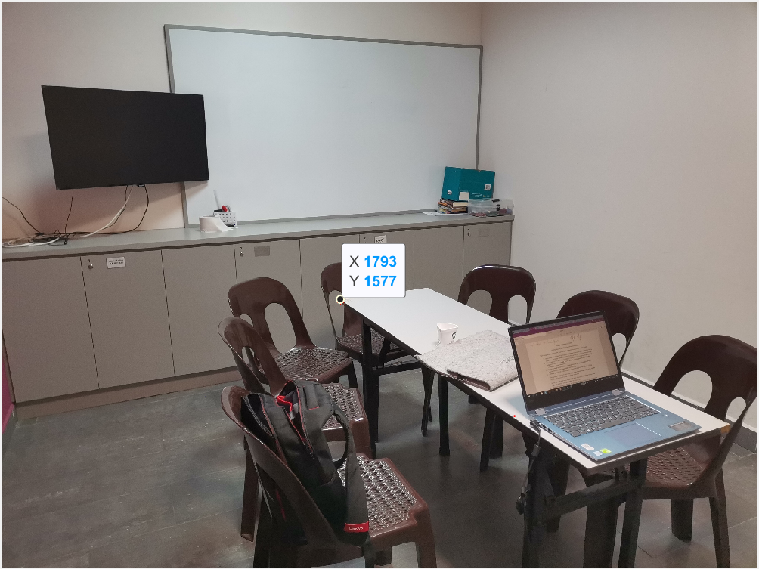

Figure 9

Its homogenous coordinate is (1793,1577,1). Substitute it into fundamental matrix equation:

$$xF'{x'}^{T}=0$$

$$x\left(\begin{matrix}0.000000051279938 & 0.000001081891828 & -0.000910426999744 \\ 0.000000709421452 & -0.000000098521164 & -0.006672390044472 \\ -0.000226724040197 & 0.002912066941439 & 1.000000000000000\end{matrix}\right)\left(\begin{matrix}1793 \\ 1577 \\ 1\end{matrix}\right)=0$$

$$x\left(\begin{matrix}0.000887661341423 \\ -0.005555765257998 \\ 5.185813362576942\end{matrix}\right)=0$$

Therefore we have:

$${0.000887661341423x}_{1}-0.005555765257998x_{2}+5.185813362576942\left(1\right)=0$$

$$x_{2}=\frac{0.000887661341423x_{1}+5.185813362576942}{0.005555765257998}$$

Plot the line on top of the image L, we obtain:

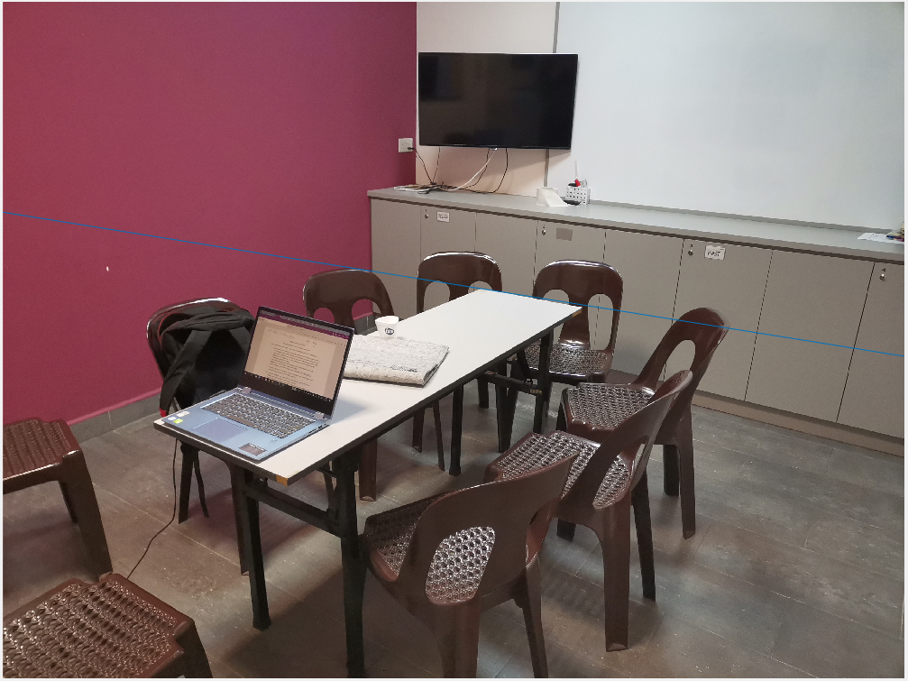

Figure 10

As we can see that the line (in blue colour) passes through the same object (top-left corner of the table). Therefore, it is the correct epipolar line.

Part III: Determining the epipolar line on the left image

A point from image R is selected to be (1201,1948). On image R it corresponds to the finger print scanner of the laptop:

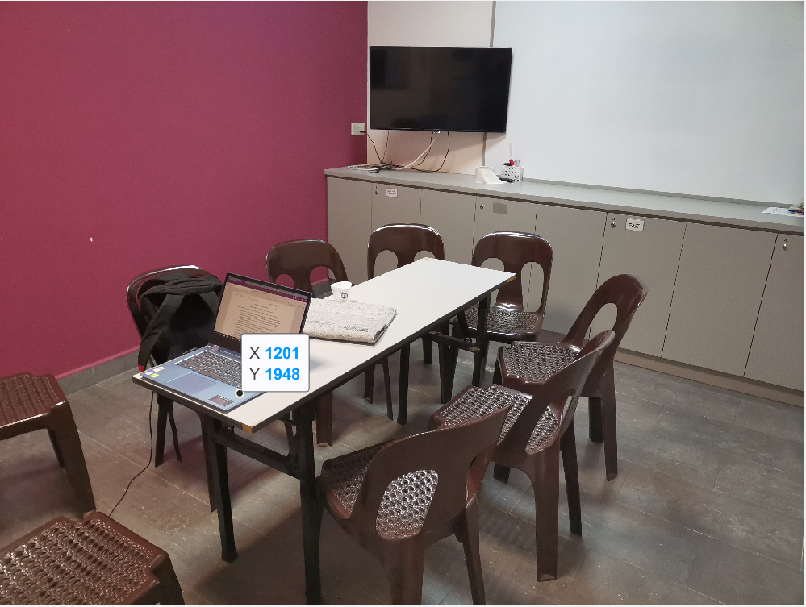

Figure 11

Its homogenous coordinate is (1201,1948,1). Substitute it into fundamental matrix equation:

$$xF''{x'}^{T}=0$$

$$\left(\begin{matrix}1201 & 1948 & 1\end{matrix}\right)\left(\begin{matrix}0.000000051279938 & 0.000001081891828 & -0.000910426999744 \\ 0.000000709421452 & -0.000000098521164 & -0.006672390044472 \\ -0.000226724040197 & 0.002912066941439 & 1.000000000000000\end{matrix}\right){x'}^{T}=0$$

$$\left(\begin{matrix}0.001216816153110 & 0.004019499798252 & -13.091238633323350\end{matrix}\right){x'}^{T}=0$$

Therefore we have:

$${0.001216816153110x'}_{1}+0.004019499798252{x'}_{2}-13.091238633323350\left(1\right)=0$$

$${x'}_{2}=\frac{{-0.001216816153110x'}_{1}+13.091238633323350}{0.004019499798252}$$

Plot the line on top of the image R, we obtain:

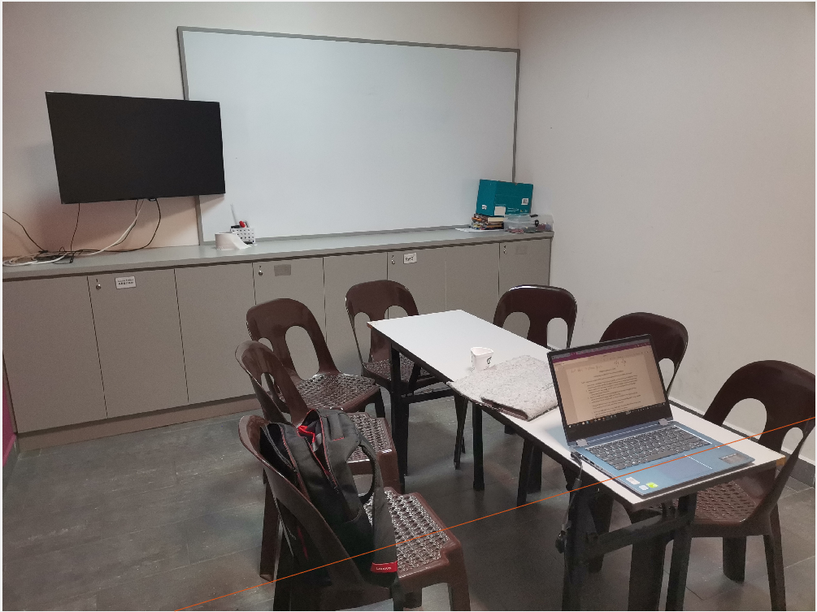

Figure 12

Evidently, the line (in brown colour) passes through the same object (finger print scanner of the laptop). Therefore, it is the correct epipolar line.